KENYA INSTITUTE OF SPECIAL EDUCATION VISION CENTRE TOOLS AND TEMPALTE

VISION CENTRE NEW CLIENT PROCESS FLOW

Basic Eye Assessment (V/A, Eye complaints, Diagnostics)
Consultation Room 1
New Client enters Service point
Vision

Service Point Customer Care Desk/Departmental Receptionist

Functional Educational Assessment
Consultation Room 2B
Clinical Assessment (Optical/Medical intervention)
Consultation room 2A

Medical Intervention
External referral
Internal referral
Optical service
Internal referral

Billing
Client Follow up
Booked for collection
Dispensing room
Client Follow up

Waiting Bay for collection from workshop
Payment
Pharmacy

- Service Point Stage: Customer Care and Service Provider  Purpose: To confirm client readiness for service, ensure accurate linkage between payment and service delivery, and initiate baseline or initial assessments aligned with the client’s needs.  Customer Care / Service Point Reception Desk  - The client produces the booking card having a unique identifier  - Retrieve and review the client record in HMIS using the identifier  - Confirming: Basic biodata and triaging outcome,  - Confirm Signposted service and queue,  - Confirm Payment status and coverage confirmation,  - Confirm referral notes from intake or payment administrator.  - Confirm service availability: Check assessor, therapist/clinician, and room allocation (for initial/baseline assessment).  - If service is temporarily unavailable, record the reason (e.g., full schedule, equipment downtime, staff absence)- Sensitize the client on the next available slot or alternative service option.  - Sign in the client for the session in the HMIS, marking the date, time, and attending | - Assessment – Basic Eye Assessment (V/A, Eye complaints, Diagnostics tests)  - WHERE – Basic assessment is done in consultation room 1  - WHO – The basic eye assessment is done by the technician /Vison therapist /Vison Assessor by use of the basic assessment tool {To be developed} (The tool will guide where the Patient goes next; Clinical /Functional Assessment  - Clinical Assessment  - WHERE - To be done at the consultation room 2A.  - WHO - This will be done by Optometrist/OCO/OPhthamologist by use of the clinical assessment tool. {To be developed} (The tool will guide where the Patient goes next; For optical or medical intervention)  - Patient gets a prescription for medical/Optical service or referral  - Functional Educational assessment  - WHERE -To done at the consultation room 2B  - WHO-Done by the Educational assessor by use of the Functional assessment tool (The tool will guide where the patient goes next; Referred Internally or Externally or Get educational report)  - Internal Referrals  - Referred to other domains  - Pharmacy  - External referral (school placement or other KISE satellite centers)  - For school placement  - For further medical assessment and interventions
C. Optical/Medical Intervention  1. Optical service  - WHERE -Dispensing room  - The client chooses the frame by guidance of the Optical Dispenser  - Billing  - Gets the total cost of both the prescription lenses and Frame  - Payment is done.  - After confirmation of payment the order is send to the workshop  - Waiting bay-Client Wait for specs/ Get Booked for picking  - Client waits for the spectacles from the workshop or gets appointment for spectacle picking  - Client receives the spectacles and dispensing service and education administered | 2. Medical service  - Billing  - Gets the bill for the medical prescription  - Payment is done  - Collect the drugs from the pharmacy

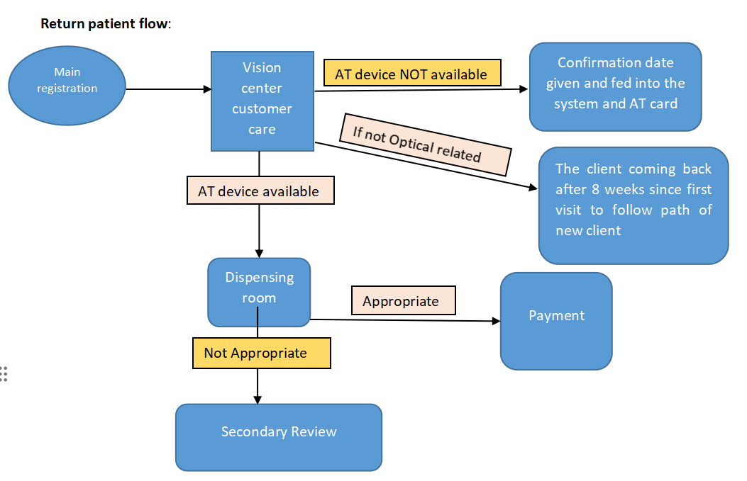

The client flow;
- Main registration
- Customer care personnel requests for the client to display the AT or TCA card. The AT card is for picking assistive devices and TCA or booking card is for the client to get a service which then the client is billed.
- Details are confirmed and client directed to the vision center customer care desk
- Vision center customer care desk
- Vision center customer care personnel confirms the availability of the AT devices in the system.
- If AT device is confirmed to have been delivered or available client directed to the dispensing room.
- If AT devices are not available or not yet delivered a confirmation date is given and fed into the system and indicated on the AT card.
- Dispensing room
- Client is assessed with the AT device. If not appropriate the client specific needs the client is queued for a secondary review. If the AT device is confirmed to be appropriate the client is given a follow up date and directed to the customer care desk for payment.
- Payment
- The customer care personnel confirm the cost of the AT device and once payment is made a receipt is given as proof of payment

TEMPLATES AND TOOLS
Basic eye assessment tool
TOOLS
TEMPLATES
Clinical Assessment tool

Functional Education assessment tool
Inventory/stock tool
RX Template

Referral form
Order template -To the Diagnostic template
Order template -To the workshop

Product order template (Bulk)
Placement Form

BASIC EYE ASSESSMENT TOOL

Client Information
- Client’s Name: ______________________________________
- Date of Birth: __________________ Age: __________
- Contact: ___________________________________________

Presenting Complaints
(Describe the main issues reported by the client — e.g., blurred vision, pain, redness, discharge, double vision, etc.)
Visual Acuity (VA)
(Record using Snellen chart or equivalent)
Eye | Distance VA | Near VA
Right Eye (RE): | __________ | __________
Left Eye (LE): | __________ | __________

Other Observations / Findings
Assessor Details
- Assessor’s Name: ____________________________________
- Signature: ____________________
- Date of Assessment: ____________________

Functional Educational Vision Assessment (FEVA)
Part A: Client Information
Field Details
Student’s Name __________________________________
Date of Birth / Age ____________________________
School / Class ____________________________
Primary Visual Condition ____________________________
Additional Disabilities (if any) ____________________________
Part B: Medical & Vision Background
Aspect Findings / Notes
Medical History __________________________________________
Source of Eye Report __________________________________________
Uncorrected Visual Acuity (Far) RE: _____ LE: _____ BE: _____
Best Corrected Visual Acuity (Far) RE: _____ LE: _____ BE: _____
Near Visual Acuity (Functional) RE: _____ LE: _____ BE: _____
Functional Contrast Sensitivity ☐ Normal ☐ Mild Difficulty ☐ Marked Difficulty
Functional Colour Perception ☐ Normal ☐ Some Difficulty ☐ Poor
Light Sensitivity / Glare ☐ None ☐ Mild ☐ Severe Details: ___________
Part C: Observable Visual Behaviors
Behavior Yes No Comments
Unusual eye appearance / movement ☐ ☐
Unusual head posture while viewing ☐ ☐
Brings materials close or far to see ☐ ☐
Frequently rubs eyes / blinks / squints ☐ ☐
Excessive tearing or discharge ☐ ☐
Bumps into obstacles or misjudges space ☐ ☐
Sensitivity to light or glare ☐ ☐
Part D: Functional Vision Abilities
Key: I = Independent V = Verbal Prompt P = Physical Prompt NA = Not Applicable NP = Not Performed
Functional Area Skill / Behaviour Performance Notes
Visual Awareness Responds to light or movement ___
Maintains gaze on objects / people ___
Tracking & Eye Movement Follows moving object horizontally / vertically ___
Shifts gaze between near and far ___
Recognition &
Discrimination Recognizes familiar people / objects ___
Differentiates by colour / shape / size ___
Visual Efficiency Maintains attention on visual tasks ___
Adjusts distance / angle for clarity ___
Shows visual fatigue (eye rubbing, blinking) ___
Use of Vision for Learning Locates materials on desk or board ___
Identifies letters / symbols / pictures ___
Uses visual aids / residual vision effectively ___
Part E: Access & Environmental Observation
Area Observation / Need
Lighting ☐ Adequate ☐ Too bright ☐ Too dim ☐ Needs glare control
Contrast ☐ Adequate ☐ Needs high contrast materials
Seating / Positioning ☐ Preferential seating needed………………………………………. ☐ Not required
Learning Materials ☐ Large print ☐ Braille ☐ Audio ☐ Digital
Technology Use ☐ Magnifier ☐ CCTV ☐ Screen Reader ☐ None
Part F: Orientation, Mobility & Daily Living
Area Skill Performance Notes
Orientation & Mobility Moves safely in familiar areas ___
Avoids obstacles / uses landmarks ___
Activities of Daily Living Locates personal items visually / tactually ___
Performs self-care tasks independently ___
Part G: Social & Emotional Functioning
Area Notes
Interaction with peers __________________________________
Confidence / Self-advocacy __________________________________
Behaviour during visual tasks __________________________________
Assessor’s Name ____________________________
Date of Assessment ___________________________

Clinical assessment visions screening tool
Patient information.
Name______________________________________
Gender_________Age_________Date____________
KISE Number________________________________

Chief complaint
History of the complaints

Visual Acuity
RE | 6/4, 6/6, 6/7.5 6/9, 6/12, 6/15, 6/18, 6/24, 6/30, 6/36, 6/48, 6/60 CF 5M, CF 4M, CF 3M, CF 2M, CF 1M, CF N, HM, PL, NPL
LE | 6/4, 6/6, 6/7.5 6/9, 6/12, 6/15, 6/18, 6/24, 6/30, 6/36, 6/48, 6/60 CF 5M, CF 4M, CF 3M, CF 2M, CF 1M, CF N, HM, PL, NPL
BE | 6/4, 6/6, 6/7.5 6/9, 6/12, 6/15, 6/18, 6/24, 6/30, 6/36, 6/48, 6/60 CF 5M, CF 4M, CF 3M, CF 2M, CF 1M, CF N, HM, PL, NPL

Slit lamp examination
 | RE | LE
Eyelid
Eyelashes
Cornea
Conjunctiva
Iris
Pupil
A/C
P/C
Sclera
Retina

RE |  |  |  |  |  | LE
SPH, -1.00, +0.75 | CYL -4.00, +3.25 |  | AXIS 90, 135 | ADD +2.75, +1.50 |  | SPH -3.75, +2.00 | CYL -1.00, +0.50 | AXIS 180, 45 | ADD +3.00, +1.50
PD |  | 20, 37 |  |  | PD |  |  | 20, 37
SH 12-28
Refraction
Imp
Diagnosis | URE, Pterygium, Cataract

Plan
Medication | RE/LE/BE | Frequency | Duration
Maxitrol | BE | qid | 1/12
Dexamethasone

Diagnostics

VISUAL FIELD

RE LE

IOP
RE | LE

Pachimetry
Attachemnts or Uploads

OCT
Filled by the Specialist (Optometrist/Ophthamologist/OCO

Referral( Pull data from referral template)
From
To
Why

OPTICAL INVENTORY TOOL
Client Name ………………………….. Phone No………………….. Sex…………………..Age………Date……..….
- Frames YES NO
- Frame type: Full frame Rimless supra
- Frame Brand/Model:
- Entry Frames
OPH OG Lantis
- High Ends
Kodak Clarity Legend
- Lenses YES NO
- Single vision
Sphere YES NO VALUE (Fill as per prescription)
Cylinder YES NO VALUE (Fill as per prescription)
Axis YES NO VALUE (Fill as per prescription)
- Availability
Instock
Oversees
- Coating
Photogrey Brown Polarised
- Tint
Blue Yellow
- Bifocal
Sphere YES NO VALUE (Fill as per prescription)
Cylinder YES NO VALUE (Fill as per prescription)
Axis YES NO VALUE (Fill as per prescription)
Add YES NO VALUE (Fill as per prescription)

- Progressive
i. Sphere YES NO VALUE (Fill as per prescription)
ii. Cylinder YES NO VALUE (Fill as per prescription)
iii. Axis YES NO VALUE (Fill as per prescription)
iv Add YES NO VALUE (Fill as per prescription)
- Accessories YES NO
Cods hard case Cleaning Cloth
- Dinspensing
- Within
-Instant ( Calender)
-Booked to pick ( Calender)
(Ii) Outsourced
- Booked to pick ( Calender)

- GLazing/Fitting YES NO

OFFICIAL USE
Operator Name ………………………..
Sign…………………………………………….

RX GLAZING FORM TEMPLATE
REF NO.------------------------
DATE ……………………………..
SHOP NAME ……………………………………………… SHOP REF NO………………………
PRESCRIPTION

 | SPH | CYL | AXIS | ADD
R.E
L.E
 | R.E PD |  | R.E Fitting Height
 | L.E PD |  | L.E Fitting Height

A.TYPE OF LENSES
Single Vision
Progressive
Bifocal

B.GLAZING TYPE
Full Frame
Rimless
Semi-Rimless

    - FRAME DETAILS
Frame material Metallic Plastic

SPECIAL INSTRUCTIONS ……………………………………………………………………………………………………………………………………..

OFFICIAL USE

TIME IN …………………………………. TIME OUT……………………………………………….

OPTICAL PRODUCTS ORDER FORM

Prescription Information (LENSES) (Price list per catalaogue)
Typ | Eye | Sphere (SPH) | Cylinder (CYL) | Add | Coating | Tint | Qty | Unit Price (Ksh) | Total (Ksh)
Single vision | Right (OD)
 | Left (OS)
Bifocal | Right (OD)
 | Left (OS)
Progressive | Right (OD)
 | Left (OS)

Subtotal: Ksh ___________

FRAMES DETAILS(Price list per catalaogue)
Frame Type ( Full frame, rimless,Semi-full ) | Brand | Model/Code | Color | Size | Quantity | Unit Price (Ksh) | Total (Ksh)
Full frame
Rimless
Supra/Semi
Subtotal: Ksh ___________

ACCESSORIES (Price list per catalaogue)
ITEM | Brand | Color | Size | Quantity | Unit Price (Ksh) | Total (Ksh)
Cases
Spectacle Cods
Cleaning Cloth

Subtotal: Ksh ___________
Total Amount: Ksh ___________
Payment Status: ☐ Paid ☐ Pending ☐ Deposit _______________________________

OFFICIAL USE
I confirm that the above order details are correct.
Signature: _______________________
Date: ___________________
Date Ordered: _______________________________
Expected Delivery Date: _______________________________

